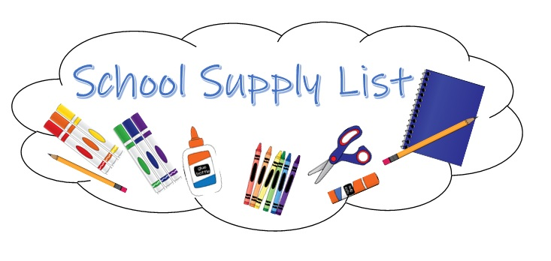

Daily Living Items  Every Student will need 1 of each of  these items on the right in addition to  the grade level supplies | 1 Box Tissues  Clorox Disinfecting Wipes  Gallon Ziploc Bags  Sandwich Ziploc Bags  Roll of Paper Towels  Book Bag

 | 6 Small Glue Sticks  1 Pair of Scissors  2 Packs #2 pencils (sharpened)  2 Spiral Notebooks  1 Supply Box (8.25 X 5 inches)  4 Black Dry Erase Markers | 2 Sets of Headphones (no ear buds)  2 Folders (3 prong - any solid color)  2 Boxes of Crayons  1 Complete Change of Clothes (shirt,  pants, underclothes, socks in a  Ziploc bag to be kept in book bag)

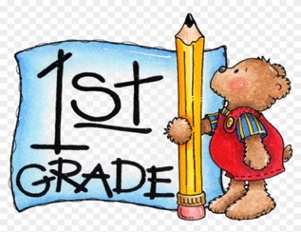
 | 2 Sets of Headphones  (no earbuds)  1 Pair of Scissors  1 Pack Dry Erase Markers  1 Supply Box | 2 Boxes of Markers  1 Pack of Water Colors  2 Boxes of Crayons (24 each)  1 Composition Notebook (lined)

 | 1 Set of Headphones (no earbuds)  2 Packs #2 pencils (sharpened)  1 Wide-lined Composition  Notebook  1 Pair of Scissors  2 Pocket Folders | 2 Boxes of Crayons (24 each)  1 Supply Box  6 Glue Sticks  8 Dry Erase Markers  Binder

Over →

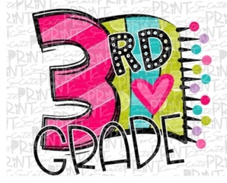 | 1 Pair of Scissors  4 Packs of #2 Pencils  (sharpened - 12 Pack)  6 Glue Sticks  1 Set of Headphones  (no earbuds)  2 Spiral Notebooks  1 School Supply Box  1.5” Binder | 1 Box of Colored Pencils or  Markers  4 Highlighters  8 Black Dry Erase Markers  2 Composition Books  2 Boxes of Crayons (24 each)  3 Folders - 2 pocket (any color)  1 Bottle of Hand Sanitizer

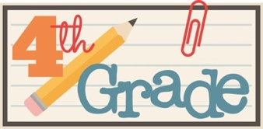 | 1 Zipper Binder  2 Black Dry Erase Markers  2 Boxes of Colored Pencils  3 2-pocket, 3 hole-punched Folders  3 Composition Books (lined)  1 Bottle of White Glue  1 Pair of Headphones | 2 Highlighters (any color)  1 Pack of wide-ruled loose-leaf  Paper  1 Pair of Scissors  36 #2 Pencils (sharpened)  1 Pencil Sharpener  1 School Box  1 Pink Eraser (large)

 | 2 Pocket Folder with prongs  2 Composition Notebooks  2 Spiral-bound Notebooks  Colored Pencils (12 Pack)  Pencil Pouch  I Pair of Scissors | Washable Markers  Highlighter  24 #2 Pencils (sharpened)  Glue Sticks - Large  Post-It Notes  Headphones

